Data Science Internship Report
- Introduction
Throughout the Spring 2026 semester, I have been working on a Data Science internship under Dr. Che. The purpose of this report is to share some of my findings and important regarding my chosen topic: Regional Meteorological Impact Analysis: Comparing Recurrent Neural Architectures and Gradient Boosting for NYC Temperature and Commerce Inferences. I was inspired to work on this topic after a particularly cold day at the start of the semester, which then led to a “lightbulb moment”: using climate data as the foundation of my research project. I figured this would be a great topic as its importance is immense in everyday life for all on the planet, as we are all at the whims of mother nature.
To maintain consistency across various climate variables, I developed what I came to call Standard Operating Processes (SOP) for all my predictive models. These consist of:
- Station Mapping & Extraction: Identifying NCEI station codes and isolating relevant regional CSVs into a structured directory.
- Feature Engineering (Temporal & Cyclical): Creating "Lag Features" to capture sequential patterns and applying $np.sin$ / $np.cos$ transformations to represent the circular nature of the calendar year.
- Model Architecture (XGBoost): Implementing a Gradient Boosting Regressor with 200 trees and a 0.05 learning rate, utilizing an 80/20 train-test split.
- Verification & Visualization: Implementing file-check protocols and generating performance graphs via Matplotlib.

- Data Sourcing & Initial Challenges
My original idea was to attempt to predict the temperature at a specific location. I scoured the internet to attempt to find a climate dataset in for the United States from around 1980 to present day. This brought about the first challenge of the research as many of the datasets I found did not work well with what I wanted to do. This was because the datasets usually didn’t focus on what I was searching for, it was either too focused on a topic related to climate or wouldn’t fit the time constraints I wanted to focus on. This then led me to search on Google for some datasets and eventually found the first dataset I began working with from the National Center for Environmental Information. The dataset contained many weather stations csv’s from all over the world and their daily climate information for my purposes I was only working with the maximum and minimum temperature. Therefore, I knew that I would eventually need to clean the dataset and only keep what I needed from it. However, since my first constraint I decided to work with was a specific location, I began by looking up the station codes for a handle of locations. While completing the standard operating steps, I placed all the extracted station csv’s inside a new folder, which I named extracted_stations, in this folder I then renamed the csv files from their station code to their locations, to make it easier to quickly read and know which location I was working with.
Eventually, I stopped working with this dataset because of the significant inconsistencies that compromised the model’s accuracy. After following the SOP, I was disappointed to find an average prediction error of 10.07°F as seen by Figure 1.1.
After trying to figure out why the average prediction error was so high, I came across some potential critical flaws:
- Unit Scaling: The NCEI data was recorded in tenths of a degree Celsius. This meant that a temperature of 25°C was represented as 250, which likely confused the model’s gradient calculations.
- Data Type Inconsistency: Some CSV files stored temperature values as a string and another as a float. This might have caused the data to be treated as objects during concatenation and XGBoost treats object columns differently, which could be causing an issue with mathematical calculations.
Therefore, to solve these issues, I pivoted to using a new dataset I found on Kaggle, which focused specifically on U.S. weather stations from 1992-2021. From this dataset I extracted relevant data and refined it into a file named mid_atlantic_weather.csv.

- Temperature
While adhering to the SOP, I re-trained the model on this new cleaned dataset. This iteration achieved an average prediction error of 1.16°F. I figured with a higher-performing model, as seen by Figure 1.2, identifying which neighboring location most heavily influenced the predictions for Central Park, NYC. The primary findings revealed that Newark, New Jersey was identified to be the top predictor by a significant margin as seen in Figure 2.1. However, given Newark’s extreme proximity to NYC, I decided to perform a second test, in which I removed Newark, leaving the remaining stations. As seen in figure 2.2, the remaining stations became much more balanced. This confirmed that physical distance is a primary determining factor in the model’s decision-making process.

- Rainfall and Commerce
Following the temperature analysis, I applied the same SOP into a predictive rainfall model. With the findings from the temperature analysis, I decided to immediately remove Newark from my findings, as it would cause the same results to appear here. I also attempted something new here because I removed the current day Pennsylvania values. This was done in effort to make the model find more complex and long ranged correlations between the stations and the NYC target. The average predictive error for the rain forecast was 1.81 mm and that along with the line graph proves the model’s accuracy as seen in Figure 3.1.
After working on these predictive models, I decided it would be a good idea to do something more practical and apply the rainfall predictive model to commerce. However, before I begin, I would like to note that this is an inference model as at first I did not have direct retail transactional data. This inference model translates meteorological variables into economic friction levels. It also assumes that weather acts as a physical barrier between traditional commerce and e-commerce.
To begin with I must define some terms:
- Low Friction: “Peak Commerce” (Precipitation: 0.0 mm)
  - The Weather: Clear skies with little to no recorded precipitation.
  - Economic Inference: This represents the “Gold Standard” for regional commerce. In high-density retail districts like NYC’s 5th Avenue or SoHo, foot traffic is at its peak.
  - Logistics: Supply chain routes—specifically those originating in the Pennsylvania “Logistics Belt” and traveling into the city—operate at maximum efficiency. Delivery windows are predictable, and transportation costs are minimal.
- Medium Friction: “The Digital Shift” (Precipitation: 0.1 mm – 5.0 mm)
  - The Weather: Light rain or intermittent showers.
  - Economic Inference: This triggers an increase in the number of food delivery orders and ride-hailing. This causes a decrease in physical foot traffic in local businesses, which then causes a surge in E-commerce and food delivery platforms.
  - Behavioral Shift: Commerce wouldn’t be stopping but would shift from face to face and in-person to digitally over your smartphone.
- High Friction: “Logistics Disruption” (Precipitation: > 5.0 mm)
  - The Weather: Heavy rain, thunderstorms, or significant snowfall.
  - Economic Inference: This represents a systematic pause in consumer spending as safety and transit reliability become the primary concerns.
  - Behavioral Shift: This is where the Pennsylvania “Front Tracker” becomes most valuable. As heavy storms in Scranton/Allentown logistics hubs create these delays at critical shipping points today resulting in potential inventory shortages and “out-of-stock” events in NYC retail locations tomorrow.

- Energy Demand and Neural Network Architectures
In the final phase of my internship, I decided that I wanted to transition from traditional Gradient Boosting using XGBoost to Deep Learning architectures in order to explore more complex, non-linear relationships in climate data and their direct impact on municipal energy requirements. Once again before I begin, I would like to note that this is an inference model as at first I did not have direct municipal energy requirements data.
To ensure proper utility for the temperature model, I implemented a calculation for Heating Degree Days or HDD. This is a crucial metric used by energy companies to estimate the fuel required for heating buildings. By setting the baseline to 65°F, the model quantifies the thermal deficit of each day. As seen in Figure 4.1, the model successfully forecasted the daily temperature fluctuations within a 1.15°F error, leading to a total predicted energy load of 16,033.8 HDD for the test period. This would then allow utilities to preemptively adjust grid capacity based on data from Pennsylvania.
The final thing I worked on was developing two distinct Neural Network models to compare their efficiency with my previous XGBoost iterations:
- Multilayer Perceptron (MLP): This is a standard deep neural network that achieved a remarkable $R^{2}$ score of 0.9927 (Figure 4.2). This in turn means that when given enough hidden layers the NYC target and the regional station data is highly structural and predictable.
- Convolutional Neural Network (CNN) Surrogate: This is typically used for images; however, I managed to adapt it to treat the 1-dimensional weather sequence as a spatial grid. It required 40 epochs of training as seen in Figure 4.3.1, but it managed to achieve a final MAE of 1.46°F as shown in Figure 4.3.2, proving that “spatial” features across the geography can be extracted as if they were pixel patterns.

- Time Series Forecasting and Comparison
After some discussion and thought, I decided it would be a good idea and use of time to predict the weather in NYC Central part by only using its previous data of said location. However, I wanted to use different models and compare them to see which model would be the best for these purposes between them all. I ended up choosing three different models: LSTM (Long Short-Term Memory), GRUs (Gated Recurrent Units), and Simple RNN.
For all three models I implemented a simple process, I gave it 80% of my dataset and had it predict the remaining 20%. The following are some observations that I noticed:
- Simple RNN: I originally expected it to fail because it lacks a memory gate and would suffer from vanishing gradients. Since it lacks internal gates like the rest of the examples it uses a hidden state to process the sequence. However, it served as a surprisingly robust baseline with a Mean Absolute Error (MAE) of 5.68°F and an $R^{2}$ score of 0.8268 which can be seen in Figure 5.1. This means the model captured the strong seasonal pattern despite its simplistic architecture.
- Long Short-Term Memory (LSTM): This was implemented to resolve the memory issues of Simple RNN. It has a simple structure consisting of three gates, being input, forget, and output, these gates allow the model to maintain a dedicated cell state to preserve information over long periods of time. This model yielded the highest precision of the three with a MAE of 5.52°F and highest $R^{2}$ of 0.8363 as seen in Figure 5.2. While it yielded the highest precision its three-gate system increases computational overhead which in turn increased the amount of time training the model. This led to this model having the longest training duration.
- Gated Recurrent Unit (GRU): this model is a streamlined alternative to the LTSM model because it merges the input and forget gates into a single updated gate. As viewed by its performance it achieves a similar accuracy, although as demonstrated in Figure 5.3, a slightly higher with an MAE score of 6.13°F and $R^{2}$ of 0.8017, yet at a much faster time.
All in all, among the three models they all have their advantages and disadvantages, nonetheless for my purpose in this case precision accuracy, I found that the LSTM is the best among the options when working with regional weather data as it provides the best predictive precision. However, depending on what one is searching for, another model could be better contingent on their purposes.

- Concluding Thoughts
Looking back at things, I have found this experience to be extremely valuable, as I am hoping for a potential career in the world of data science. After concluding things this way, I would like to note a couple of changes/things I would like to work on further: the most important would be to try and acquire dataset for the inferences I made, to see if they were accurate or not. I have grown more confident and would like to work more with Python, as the vast libraries and works have truly been a blessing. Finally, I would like to thank Dr. Che for overseeing this project, this has been a truly great experience and I hope that I can continue working with Data Science related things such as this in the future.

Figure 1.1
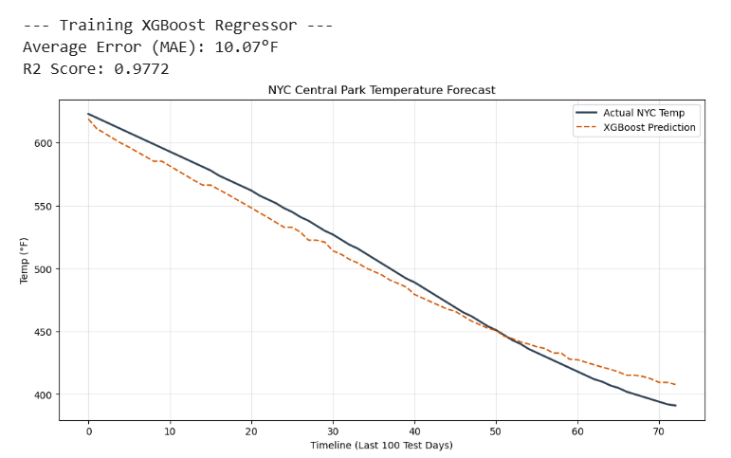
Figure 1.2
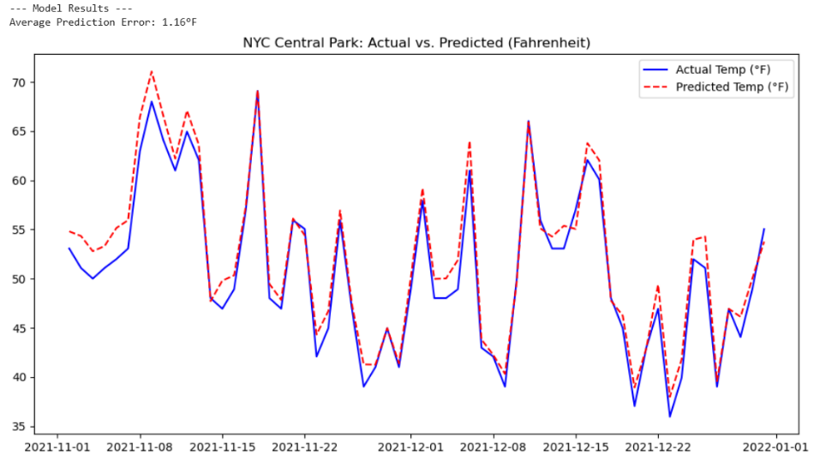
Figure 2.1
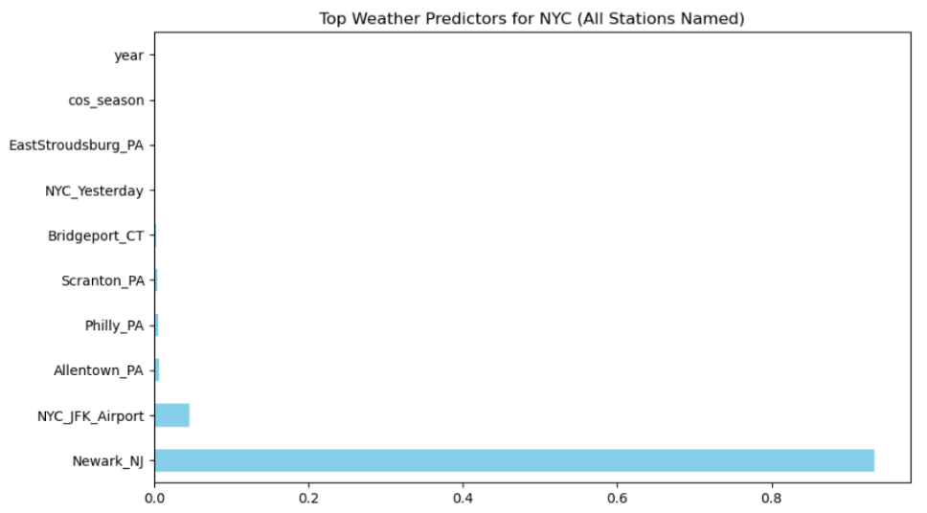
Figure 2.2
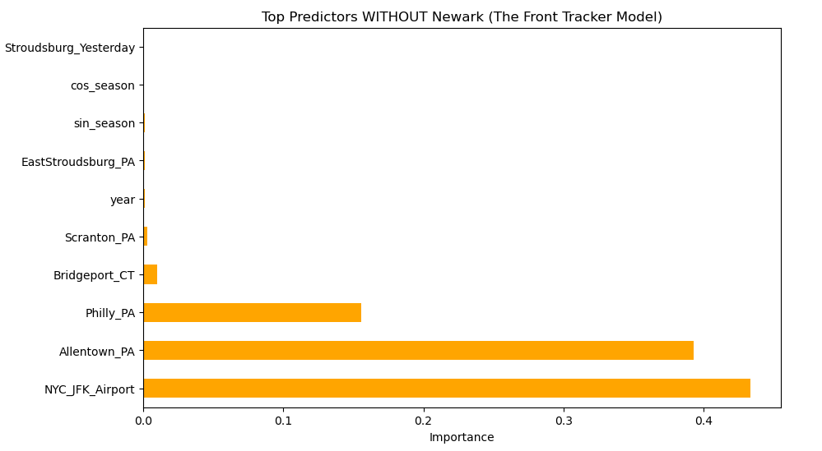
Figure 3.1
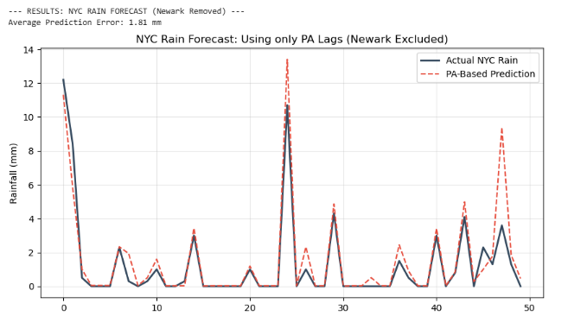
Figure 3.2
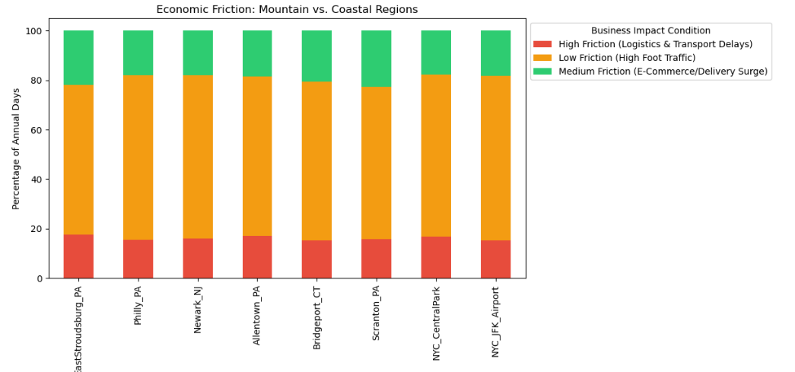
Figure 3.3
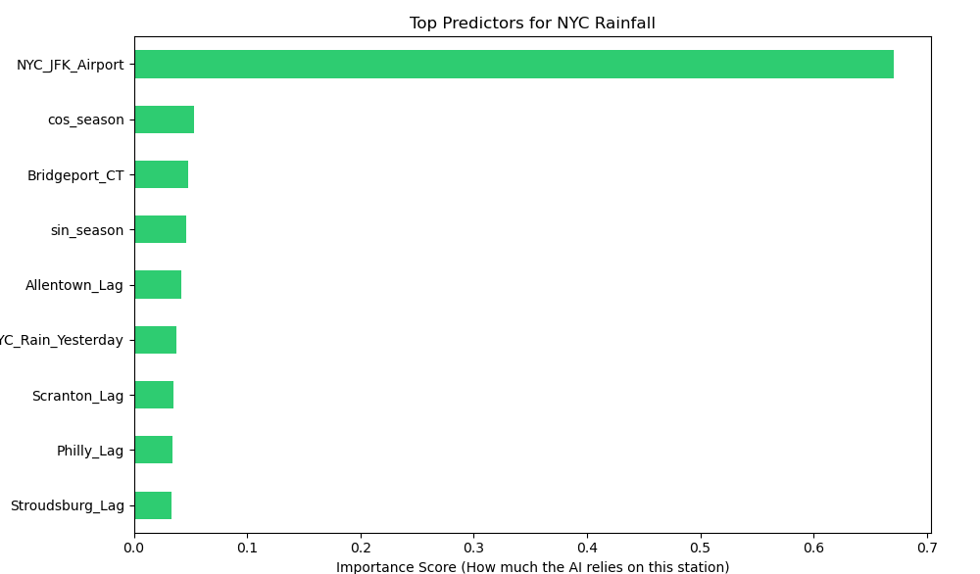
Figure 4.1
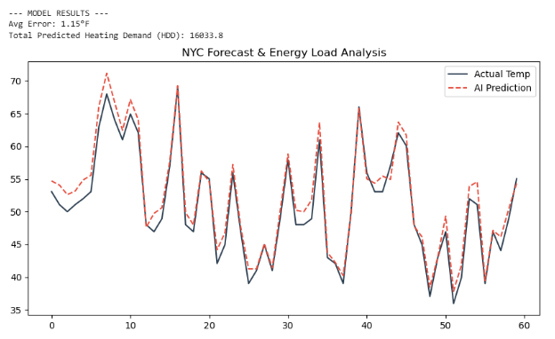
Figure 4.2
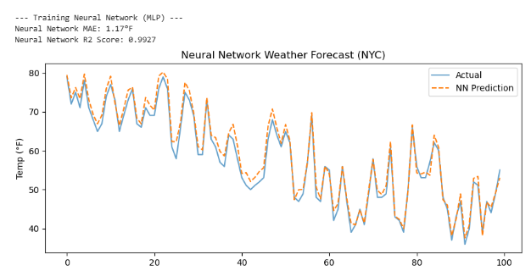
Figures 4.3.1: Training CNN Weather Model
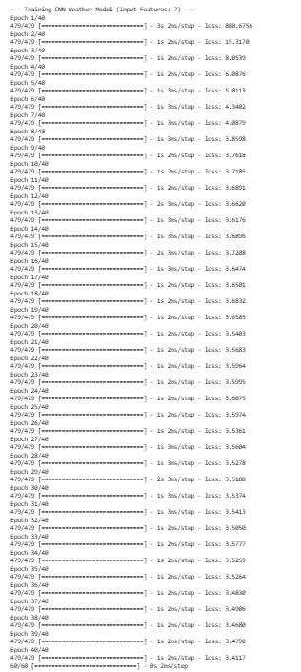

Figure 4.3.2
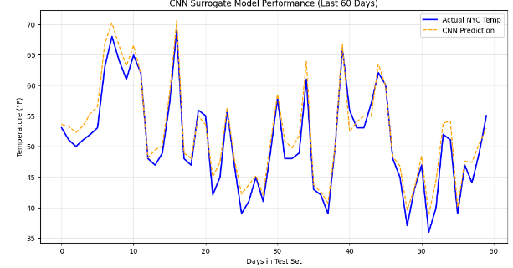
Figure 5.1
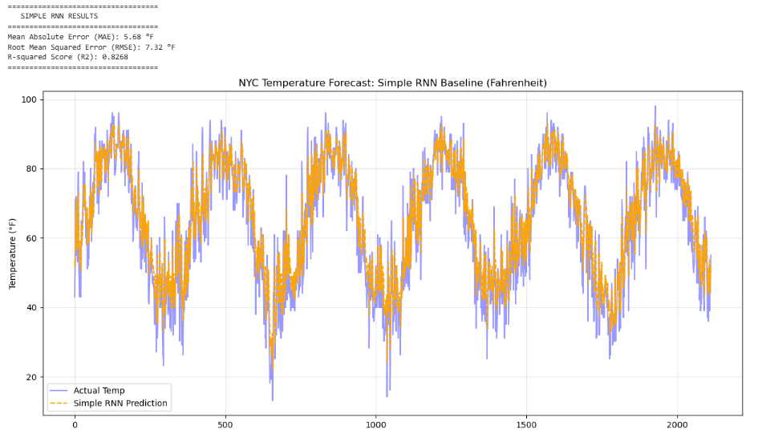
Figure 5.2
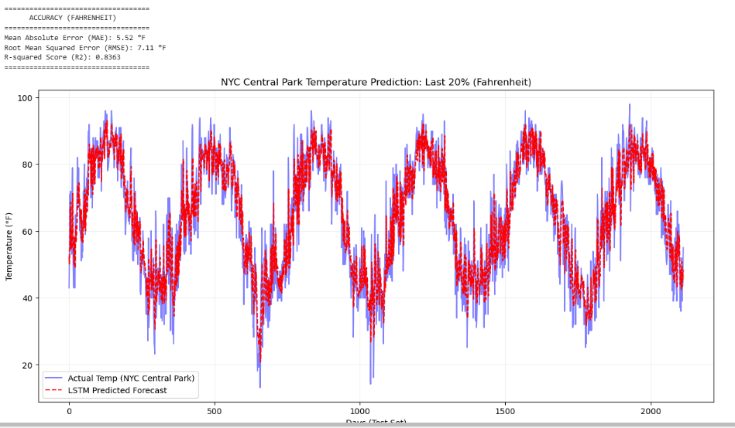
Figure 5.3
